Special Permissions in Linux

Special permissions in Linux provide additional security and control for files and directories beyond the standard read, write, and execute permissions. They include Setuid, Setgid, and Sticky Bit.

Types of Special Permissions
1. Setuid (SUID) - Numeric value: 4
2. Setgid (SGID) - Numeric value: 2
3. Sticky Bit - Numeric value: 1

Permission Symbol Representation
Below are the symbolic representations for these special permissions:
suid sgid stickybit
rwx r-x r-x
s s t
rws r-s r-t
rwS r-S r-T

1. Setuid (SUID)
Set User ID (Setuid) allows a user to execute a file with the permissions of the file owner. This is commonly used for executable files requiring temporary elevated privileges.
Commands to manage Setuid:
• Set: chmod 4755 <filename>

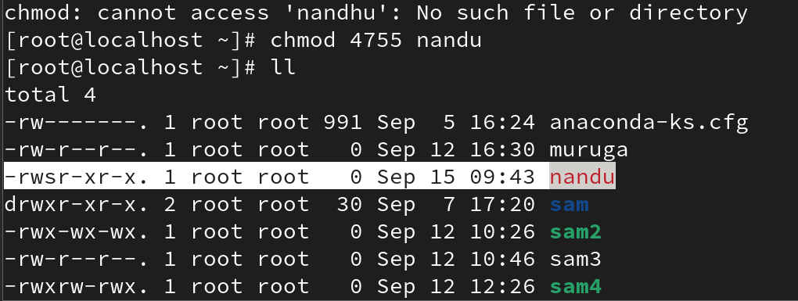

To remove permission:
#chmod 0755 <file name>

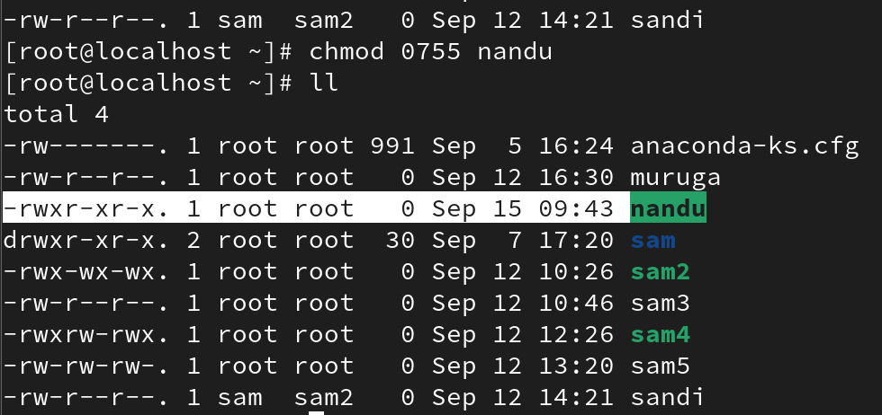

• Symbolic: chmod u+s <filename>

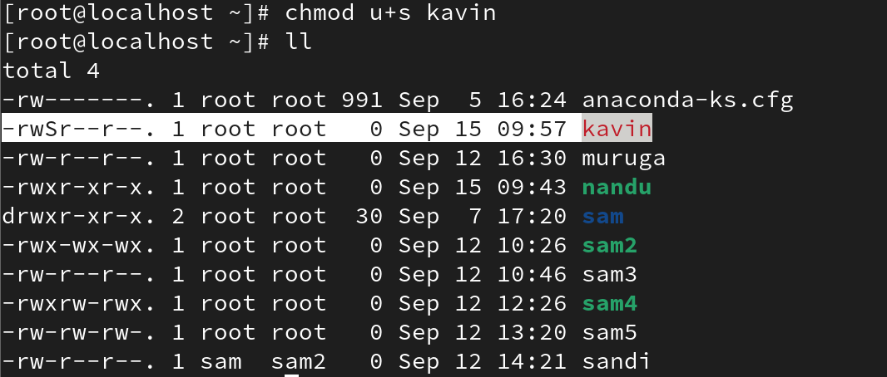

• Remove: chmod u-s <filename>

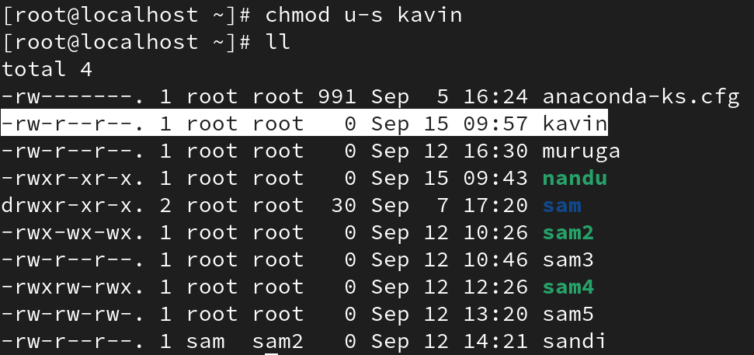

2. Setgid (SGID)
Set Group ID (Setgid) behaves similarly to Setuid, but it sets the process's effective group ID to that of the file's group owner, granting group-based permissions.
On Files:
• Set: chmod 2755 <file>

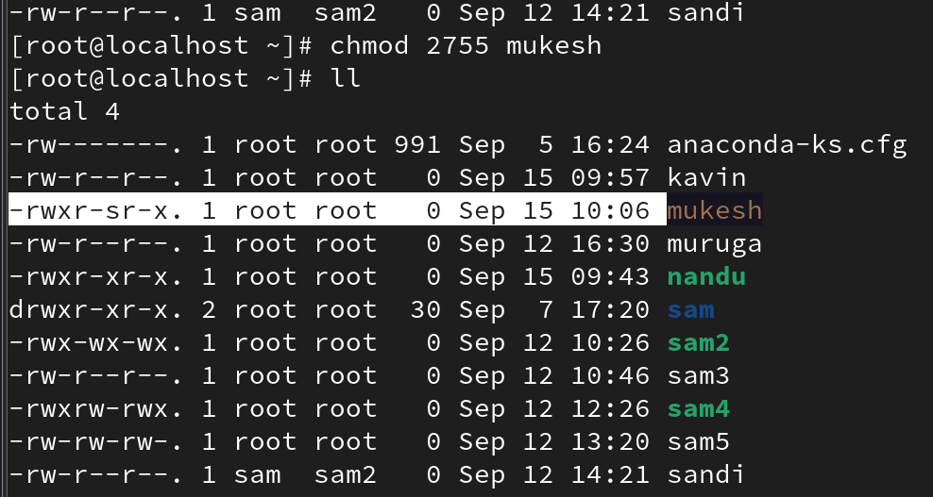

To remove
#chmod 0755 <file name>

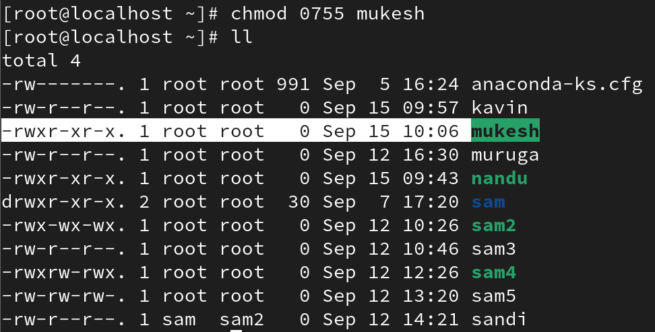

• Symbolic: chmod g+s <file>

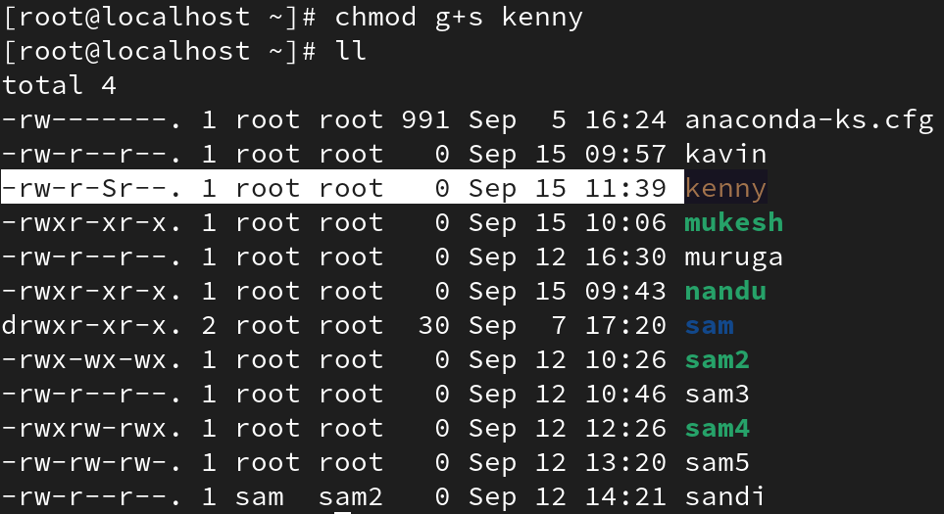

• Remove: chmod g-s <file>

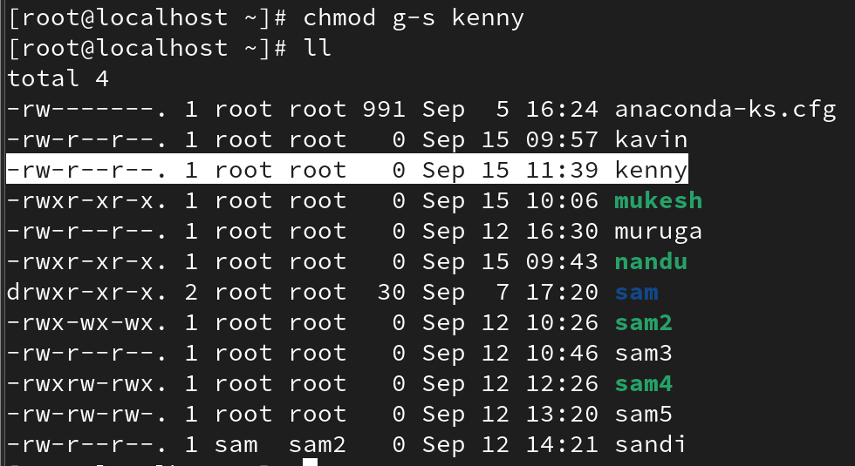

On Directories:
When SGID is set on a directory, all new files or subdirectories inside inherit the directory's group ownership.
• Set: chmod 2755 <directory>
• Symbolic: chmod g+s <directory>

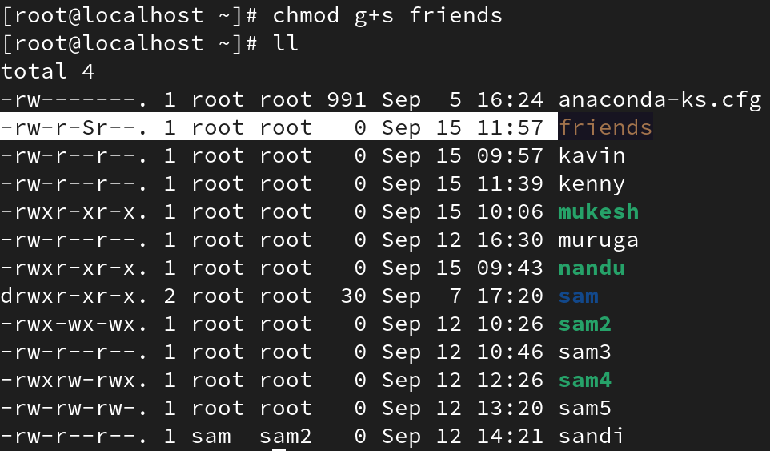

• Remove: chmod g-s <directory>

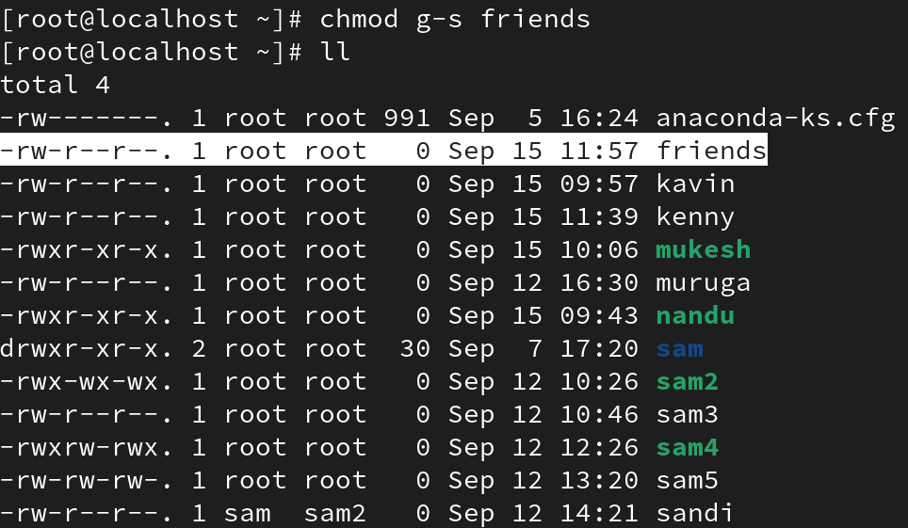

To remove or add directories with recursive files
#chmod -R <dir name>

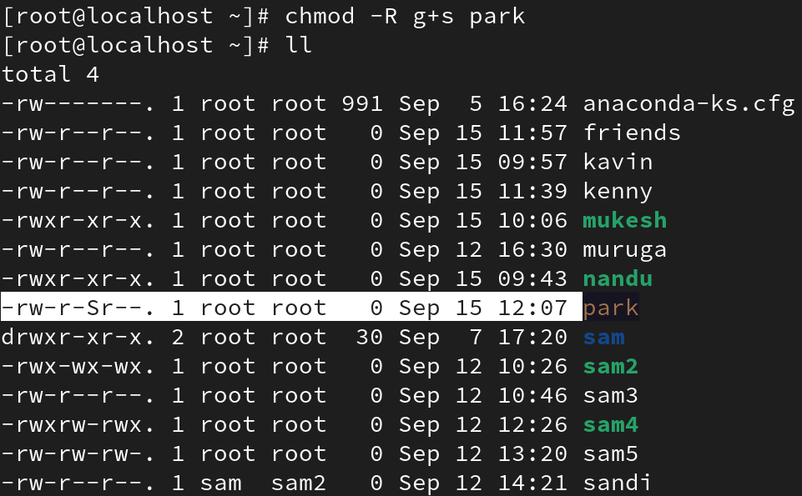

3. Sticky Bit
The Sticky Bit ensures that only the file owner or root can delete or rename a file within a directory, even if others have write permissions to the directory. It's often used on public directories like /tmp.
Commands to manage Sticky Bit:
• Set: chmod 1755 <file/directory>

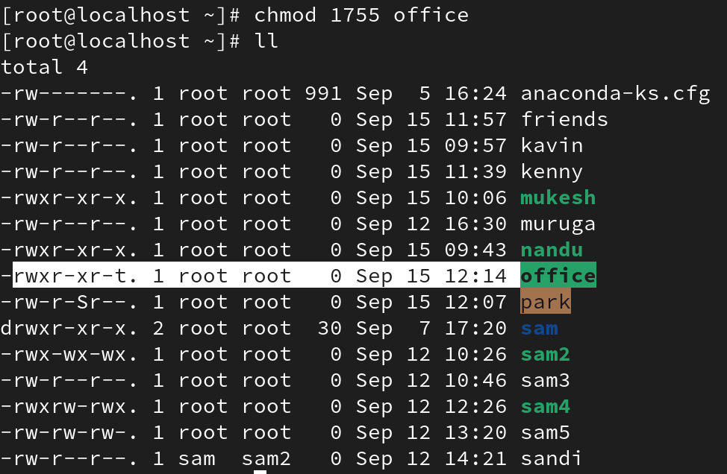

To remove
#chmod 0755 <dirname>

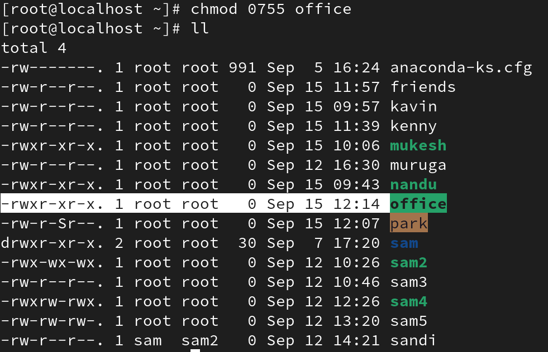

• Symbolic: chmod o+t <file/directory>

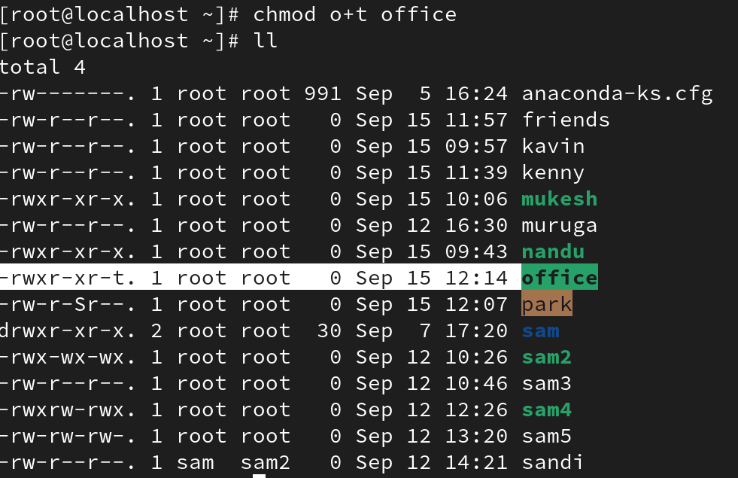

• Remove: chmod o-t <file/directory>

